**Create IBM Watson Iota Platform and Device**

|  |  |
| --- | --- |
| Team ID | PNT2022TMID50177 |
| Project Name | Smart Waste Management System for Metropolitan Cities |

Step 1: Log in to IBM Cloud  
  
Step 2: Click Catalog where you find the services and Create Internet of Things Platform  
  
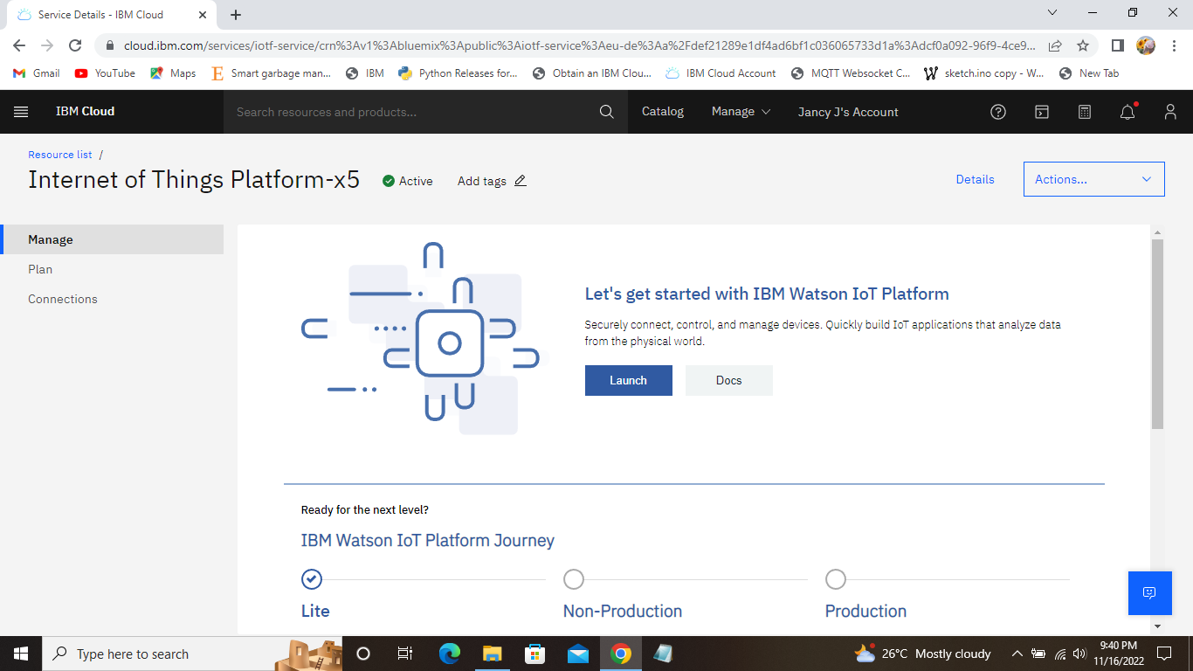

Step 3: Click the Launch tab and it redirect you to IBM Watson Iot Platform where you need to click sign in.

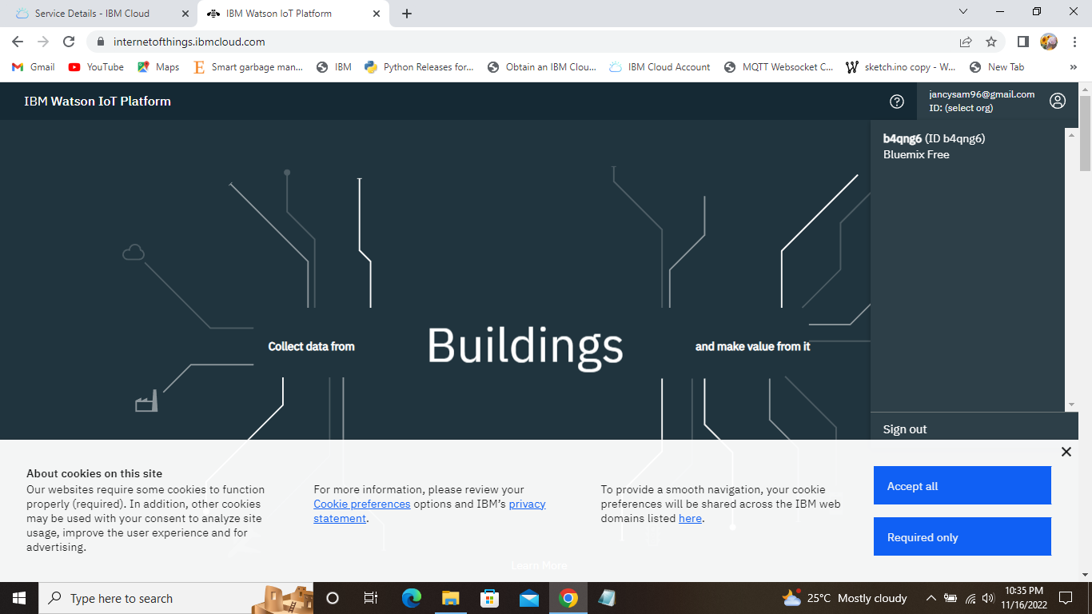

Step 4: Again you need to log in to IBM Cloud where you find the Browse Devices tab which is used to Add Device.  
  
Step 5: After clicking create a New Device / Add Device you can choose the Device type and Device ID and complete the information to create a device.  
  
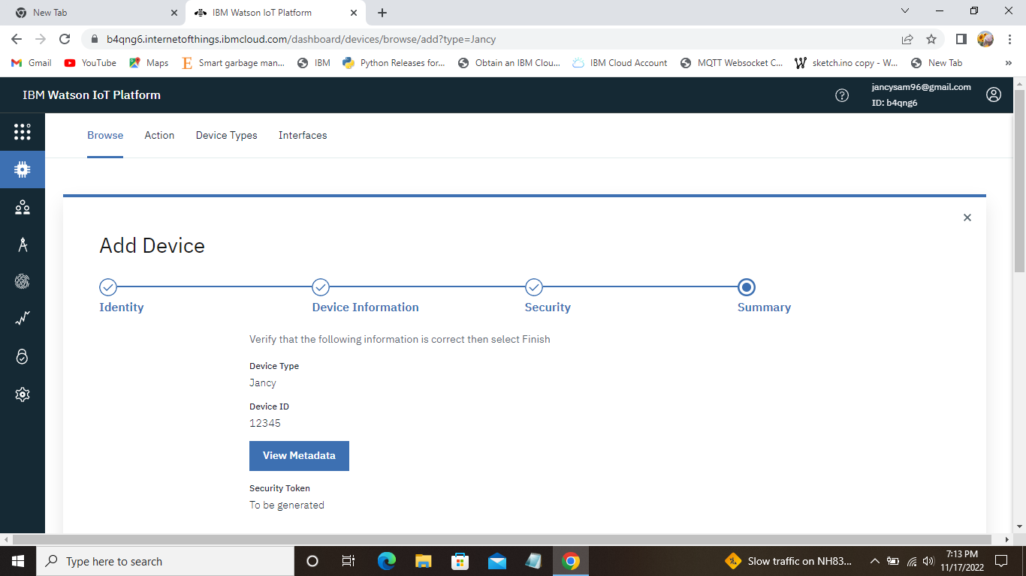  
Step 6: Once you created the Device, the Device Credentials will be shown.  
